## Linear Algebra Vectors

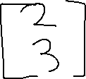

The above is a Vector in 2D coordinates plane.

2D Coordinate plane



The above means that the vector **v** with direction **east** is a member of the 2D coordinate plane or **R2**